Division of Medicine
Divisional Deputy Director of Operations




Dear Candidate,
Thank you for your interest in the role of Divisional Deputy Director of Operations at West Hertfordshire Teaching Hospitals NHS Trust. I am delighted that you are exploring the opportunity to apply. This is an exciting time to join our Senior Operational Management Team and help support our future ambitions.
I joined the Trust as Chief Operating Officer two years ago, and I was attracted by the dynamism of this high achieving trust and its ambitions for the future. We have made huge progress in recent years to improve services and waiting times for patients including:
- A top 10 performing Emergency Department: we are now consistently in the top 10 EDs in the country on the 4hr standard having climed over 100 places in the national rankings over the last 3 years.
- HSJ Trust of the Year 2025: we were awarded two HSJ awards in 2025 for Trust of the Year and Performance Recovery, reflecting innovation and improvement Trust-wide.
- Eliminating Long-Waiting Patients: The Trust elimintated patients waiting over 65 weeks for treatment in 2024 and will have done the same for patients over 52 weeks by July 2026.
- Major Estates Redevelopment: our major redevelopment programme covers all 3 of our hospital sites with new facilities open or coming soon including; surgical hub with 4 new theatres, Community Diagnostic Centre, endoscopy units, IR suite, care coordination centre and Mental Health UTC.
Delivering our Trust strategy to provide safe, high quality, timely and sustainable care requires best-in-class operational management. We face an increasingly complex landscape for operating hospital services and have set ourselves high ambitions to drive towards excellence in operational performance and management, as our patients should rightly expect.

This role will suit an exceptional operational leader with passion, ambition and the experience to support the achievement of our goals. The postholder will provide visible and transformational leadership to the clinical and operational teams within the Women’s and Children’s Division. You will find a supportive and experienced executive and leadership team motivated by effective team working and an inclusive approach. The successful candidate will play a key role in driving improvement in the emergency care access standards and transforming urgent care pathways for the benefit of our communities.
I hope that this pack will give you all the information you require but please do not hesitate to contact our recruitment team if you need any further information. We very much look forward to hearing from you.
Yours faithfully

Rachel Thorman Dr Niall Keenan
Chief Operating Officer Divisional Director for Medicine

West Hertfordshire Teaching Hospitals NHS Trust (WHTH) is a progressive healthcare provider, dedicated to delivering high-quality care to our communities. We've come a long way since emerging from special measures in 2018. Positive inspections by the Care Quality Commission, national awards, low staff vacancies, and high satisfaction scores are testaments to our ongoing transformation.
WHTH serves a core population of roughly half a million in West Hertfordshire and surrounding areas, with a mix of affluence and pockets of deprivation. We also offer specialised services to a wider region, including North London, Bedfordshire, Buckinghamshire, and East Hertfordshire.
As one of the area's largest employers, our workforce of nearly 5,000 delivers care to almost a million people annually. This includes over 150,000 emergency department visits, nearly half a million outpatient appointments, and roughly 4,600 births at our maternity units.

Our Hospitals
Our Hospitals Services are run over three hospitals: Watford General Hospital, St Albans City Hospital and Hemel Hempstead Hospital. Outpatient physiotherapy is provided at Jacketts Field in Abbots Langley.
- Watford General Hospital is at the heart of our acute emergency services - the core location for inpatient care, and for all patients who need the specialist emergency facilities (such as intensive care) of a major district general hospital.
- St Albans City Hospital is our elective care centre. It provides a wide range of planned surgical care (both inpatient low risk surgery and day-case) and a wide range of outpatient and diagnostic services with more than 100,000 outpatient appointments. The St Albans site is being developed into an Elective Care Hub for the local system.
- Hemel Hempstead Hospital offers other local healthcare facilities such as diagnostic services, including MRI and cold pathology, as well as an outpatient service that sees more than 100,000 patients per year. The site has an exciting future as a multi-specialty base for planned medical care. Redevelopment options are being explored with the local council with a view to creating new facilities in the town centre as a joint project with council and other health partners.

Leading the Way in Transforming Medical Services
The Medicine Division is at the forefront of delivering high-quality care to our community. We manage and oversee services across all three of the Trust’s hospital sites.
Our Priorities:
- Faster, Safer Care: We strive to continuously improve access times for our urgent, diagnostic, cancer and planned care services, ensuring patients receive timely and safe treatment.
- Treating Patients Closer to Home: We're actively developing strategies to provide care closer to home, reducing unnecessary hospital admissions.
- Future-Proofing Our Facilities: Our new hospital design will prioritise efficient delivery of future urgent care pathways.
- Investing in Our Workforce: We're committed to implementing a robust workforce strategy to ensure adequate staffing levels.
- Technology for Better Care: We actively embrace technology to streamline patient pathways and improve care delivery.
- Continuous Improvement Culture: We're dedicated to a Quality Improvement (QI) methodology to ensure ongoing service improvement.
Our Services:
The Medicine Division is at the forefront of delivering high quality care to our community, working with our system partners in close collaboration to provide the Right Care in the Right Place. The Division encompasses three main Specialty Groups being:
- Specialty Services, which comprises of: Dermatology, Rheumatology, Diabetes and Endocrinology, Haematology, Nephrology and Neurology.
- Care of the Elderly Services which also includes our frailty services and care of the elderly.
- Interventional – Respiratory, Gastroenterology and Cardiology
The Division is spread across three main sites with a dedicated Diabetes Centre; two dedicated Endoscopy sites; the Helen Donald Unit which is a Haematology/Chemotherapy outpatient day unit; an Acute Stroke Unit and has close connections with Tertiary Centres within both East of England and London.

The Division also leads on the nationally recognised and highly respected Virtual Hospital which enables our patients to stay in the comfort of their home whilst under our care. The Division spans complex specialities and subspecialties and is at the forefront of innovative change with several projects underway that will transform our diagnostic capabilities.

CQC Ratings
2021 CQC Inspection: Progress Towards Excellence
While our overall rating in 2021 remained "Requires Improvement," we're pleased to report significant progress. We received positive ratings of "Good" for effectiveness, care delivery, and leadership. Areas needing improvement were safety and responsiveness.
This inspection showed improvement since our last one. Four out of six core services received a "Good" rating, with only two requiring improvements.
Here's a breakdown by location:
- Watford General Hospital: All but one service achieved a "Good" rating.
- St Albans City Hospital: All three services received a "Good" rating.
- Hemel Hempstead Hospital: Two out of three services were rated "Good," with one requiring improvement.
We have a clear plan in place to address the remaining areas and achieve "Good" ratings across all services.
Hospital Redevelopment
Get ready for a transformative healthcare experience! West Hertfordshire Teaching Hospitals is undergoing a groundbreaking redevelopment plan, designed to revolutionise patient care from the ground up.
Imagine stepping into brand new hospital buildings at Watford General, equipped with the latest technology for unmatched treatment. Hemel Hempstead and St Albans City Hospital will also receive a complete makeover, boasting state-of-the-art facilities alongside strategic new builds. These facilities will be designed with your well-being in mind and will create a healing environments that promote a swift recovery for all our patients.
Dedicated urgent treatment centres will be established at both locations, ensuring swift and efficient care. St Albans City Hospital will take things a step further with a rapid access cancer diagnostic centre, expediting both diagnosis and treatment for this critical illness.
But that's not all! We're strategically realigning services across our hospitals. This means better grouping of specialties and staff, leading to enhanced efficiency and seamless collaboration. Additionally, each hospital will have a clearer focus, optimising patient care pathways for a truly streamlined experience.
This redevelopment is more than just bricks and mortar; it's about building a brighter future for healthcare delivery in West Hertfordshire.



Live, Work, Thrive in Vibrant Hertfordshire!
Imagine this: a thriving career in a modern hospital, easy access to the buzz of London, and the charm of a picturesque county – all within reach. That's the reality at West Hertfordshire Teaching Hospitals NHS Trust!
Our hospitals are perfectly positioned: close enough for quick commutes to London (Euston in just 18 minutes!), yet far enough to escape the big-city costs. Excellent rail and road links put the rest of the UK at your fingertips.
Hertfordshire offers a lifestyle to suit everyone:
- Bustling Towns & Peaceful Villages: Choose from vibrant towns like Watford and St Albans, or charming villages like Kings Langley.
- Top-Rated Schools: Hertfordshire boasts some of the country's best schools, perfect for families.
- Adventure Awaits: Explore nature trails, award-winning parks, and beautiful rivers. Hit the green on a championship golf course or try your hand at water sports.
- Family Fun: Take the kids to zoos, wildlife parks, open farms, or explore historic museums.
- Lively Entertainment: Enjoy buzzing cafes, trendy shops, and exciting markets. Cheer on Watford FC.
- Shopping Heaven: From local boutiques to major shopping centres like the Galleria and Brent Cross, you'll find everything you need.
Ready to join our team? We offer excellent career opportunities with a supportive work environment. Plus, discounted staff parking and easy access to Luton, Heathrow, and Stansted airports.
Live, work, and thrive in vibrant Hertfordshire!

https://www.westhertshospitals.nhs.uk/recruitment/aboutus.asp https://www.westhertshospitals.nhs.uk/yourvisit/ https://www.westhertshospitals.nhs.uk/about/travel_information/watford.asp


- GENERAL INFORMATION:
Job title: Divisional Deputy Director of Operations
Band: 8d
Department: Medicine
Division: Medicine
Site / base: Watford with travel to Hemel Hempstead & St Albans as required
Reports to: Divisional Director
Accountable to: Chief Operating Officer
Direct reports: Assistant Director of Operations, General Managers
DBS clearance – level required: Standard
- KEY RELATIONSHIPS:
Internal
- Divisional director
- Other Divisional Leads (DD,HON,DDO)
- Clinical leads
- Executive directors
- General / assistant general managers
- Matrons
- Heads of nursing
- Other medical and nursing staff
- Head of departments
- Other managers
- Other staff groups
- Finance managers
- HR Business partners
External
- NHS England
- Local Authorities
- South West Hertfordshire Health & Care Partnership
- Integrated Care Board
- Other trusts
- Other agencies

- JOB SUMMARY:
The purpose of this post
Do you have a passion for healthcare operational management and are you looking for a role where you can make a tangible impact on patient care, working as part of a high performing triumvirate team, in a forward thinking and ambitious organisation? West Hertfordshire Teaching Hospitals NHS Trust is seeking a visionary and experienced Divisional General Manager for Medicine to join our senior leadership team.
In this role, you will:
- Take operational leadership: Take day to day responsibility and accountability for the operational running of the Division.
- Drive performance: Monitor and manage performance metrics to ensure that patient-centered services are of a consistently high standard, while ensuring financial stability and long-term sustainability.
- Promote and drive continuous improvement: Utilise service improvement methodologies to deliver service developments that meet the Trust’s strategic objectives.
- Build a High-Performing Team: You'll lead a team of dedicated service managers, fostering a supportive and collaborative environment that prioritises patient well-being.
- Champion Collaboration: You'll establish strong links with the wider health and social care community by securing their involvement in the effective delivery of services.
- Oversee financial and productivity improvements: Provide robust financial management within the division.
This leadership role offers the perfect blend of fostering a high-performing team, driving strategic initiatives, and making a tangible impact on patient recovery during a critical time.
You will work closely with the Divisional Director in supporting the Division in ensuring the provision of high-quality patient services that are clinically sound, delivered cost effectively and meet the Trust’s priorities and performance targets.
You will provide strong local leadership to the Division and to balance strategic plans with operational needs and robust delivery.
You will provide strategic leadership at divisional level, ensure that there are appropriate systems and processes within the Division to enable staff to deliver good quality clinical care and drive forward the service improvement agenda to achieve efficiency gains and improve the operational effectiveness of the Division.

Additionally, you'll possess:
- Exceptional Leadership Skills: The ability to motivate, inspire, and empower your team is crucial.
- Strategic Vision: You'll be instrumental in shaping the future direction of the division, ensuring it remains innovative and efficient.
- Excellent Communication and Collaboration Skills: You'll foster a positive and collaborative work environment, fostering open communication across all levels.
- Commitment to Continuous Improvement: You'll be passionate about identifying and implementing strategies to optimise patient care and unit performance.

- STRUCTURE CHART
Trust Management Structure
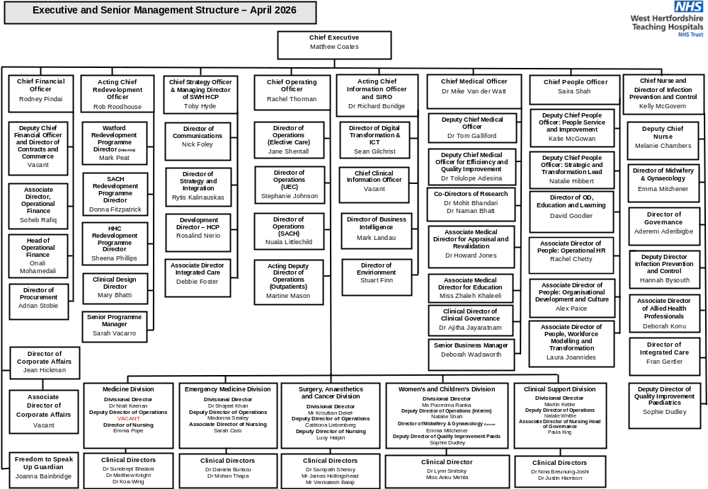
Divisional Management Structure

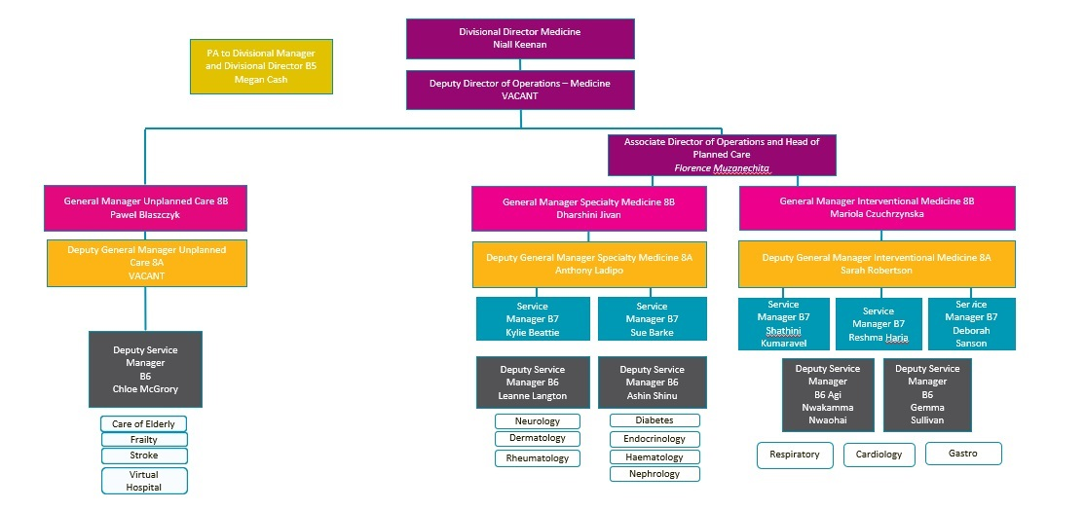

5. PRIMARY DUTIES AND AREAS OF RESPONSIBILITY:
- Take day to day responsibility and accountability for the operational running of the Division.
- Lead the Division to ensure national and local targets are achieved and that they meet the needs of the local community and the wider NHS and fulfil commissioner agreements.
- Develop and implement plans to deliver the relevant Trust objectives as required.
- Monitor and manage performance metrics to ensure that patient-centered services are of a consistently high standard.
- Provide robust financial management within the division.
- Provide leadership and management to both direct and indirect reports.
- Establish strong links with the wider health and social care community by securing their involvement in the effective delivery of services.
- Have a strong knowledge of service improvement methodologies and keep these at the forefront of service developments.
- This role profile is not exhaustive.

Strategic
- With the Divisional Director, provide leadership to the Divisional Management Team and contribute to developing the strategic direction of the Trust.
- Be accountable for the operational management of the Division.
- Take shared corporate responsibility for the financial performance of the Trust, including the achievement of financial targets, balancing the potentially conflicting demands of budgetary requirements and clinical standards.
- Ensure that there is divisional level commitment to develop plans to move the Trust to 24/7 working.
- With the Divisional Director, report to the monthly performance review on the divisional scorecard.
- Represent the Division at local levels, developing partnerships, sharing best practice, and integrating this knowledge within the Trust.
- To actively participate in the Trust Senior managers on-call rota.
- Set an example to other staff through own personal behaviors.

Operational
- External scanning regarding national performance measures and national operational agendas including key indicators in relation to the hospitals’ regulatory commitments.
- Provide effective and visible leadership and direction at all times in the operation and delivery of all services within the Division.
- Responsible for achieving key performance targets for Emergency care and the admitted bed base under the post holder’s division.
- Keep the Divisional Director abreast of relevant day to day matters relating to services and site issues.
- Ensure full compliance with the Trust’s Assurance Framework and any related standards including assurance on all corporate and clinical risks.
- Work with the Clinical Director, Head of Nursing and Clinical Leads to secure clinical engagement in the day-to-day activities of the Trust, and in performance improvements and service developments, working with the leads in other Divisions where appropriate.
- Promote innovation and quality improvement to ensure best-practice services for patients and positive working experience for staff.
- Ensure that business development opportunities for the delivery of patient services are explored, agreed, and implemented.
- Ensure that the divisional structure is fit for purpose to deliver Trust and national requirements.
- Support the Assistant Divisional Managers in delivery of their specialty access standards.
- With the Divisional Director lead on efficient job planning aligned to service needs and activity.

Communication
- Work in collaboration with divisional directors to establish effective channels of
- communication in the division to ensure the efficient management and delivery of services, and to be responsive to patients and commissioners’ views and needs.
- Sustain effective working relationships with the executive directors, divisional director, clinical directors, lead clinicians, matrons, consultant medical staff and other senior management post holders ensuring the operational requirements of the division are effectively managed and coordinated, including staff deployment and bed management. This will include collegiate working to optimise patient flow and pathways across the divisions.
- To be responsible for the handling of complaints relating to divisional services by personally supervising the quality and standard of all investigations and responses to complainants.
- To establish effective networks with other providers, and, if appropriate, the Trust Development Agency.
- Ensure systems and processes are in place to deliver accurate timely statutory information requirements including the trust data protection policy and freedom of information Acts.

Safety, quality, and patient experience
- With the Divisional Director, ensure that the division implements appropriate clinical governance structures and processes within the division and across all sites. This will cover responsibility for all clinical and non-clinical services including medical devices.
- Ensure that the working arrangements are in place to enable the division to comply with the trust’s complaints procedure; investigate and ensure feedback mechanisms are in place following a patient complaint and work with the corporate user engagement committee.
- Update and monitor the operational policies of the division and take account of risk management needs actively contribute to the development and application of systems, controls process and risk management arrangements that ensure full compliance with internal and external governance and best practice standards e.g., Health Care Commission Standards

Leadership and management
- Manage the Assistant Divisional Managers and other staff designated within the divisional role specification.
- Provide functional day to day leadership and support to the Clinical Leads, Assistant Divisional Managers and Matrons of the Division.
- Ensure the Division develops its workforce strategies and develops comprehensive workforce
- plans sufficient to meet the Trust’s strategic objectives.
- Ensure good people management practice and effective team-working is operating across the division and support the improvement of cross-divisional working.
- Ensure all people-related key performance indicators are achieved.
- Ensure feedback secured via the national staff survey, and any local staff surveys, are acted upon to deliver a continuous improvement in the staff experience.
- Promote a learning and coaching culture based on openness, learning and continuous improvement and support continuing personal development.
- Support the development of organisational processes and systems to improve organisational effectiveness.
- Ensure annual objectives are agreed with all staff within his/her line responsibility and that staff are appraised, trained and developed.
- Encourage a culture where employees are empowered to take personal responsibility, are well motivated and able to understand and commit themselves to the objectives of the Trust.
- Lead on the monitoring and management of all access standards for the Division.
- Provide direction and leadership to the divisional team, ensuring that services provided are appropriate and continuously developed and that they contribute effectively to the performance of the Trust.

People and workforce
- Fully embedding Trust values and behaviours
- Shaping and leading the Divisional workforce strategy; ensuring effective business aligned team and individual job and roster planning and ensuring that service needs are met in accordance with Trust objectives and national requirements.
- Ensuring cross-divisional delivery of the annual departmental team and individual Job Planning process and effective team rostering; ensuring compliance with Trust principles and ensuring clinical capacity meets anticipated service needs without reliance on locums and ad hoc sessions.

Financial responsibilities
- Manage and be accountable for the division’s budget in line with standing financial instructions and standing orders to keep within the divisions allocated budget.
- Deliver efficiency improvements and costs savings to meet the Trust’s annual financial plan.
- With the Divisional Director, lead the divisional annual budget setting process and delivery of savings targets.
- Develop longer-term efficiency improvement plans to support the Trust’s long-term financial model requirements and regulatory risk rating.

- On-call requirements (applicable for roles which are 8b and above only):
On-call may be required for roles Band 8b and above. This will be determined by the Head of Emergency Planning. If you are required to participate, training and induction to on-call will be provided.


Post title: Deputy Director of Operations |  | Band: 8d
Factors | Essential requirements | Desirable requirements:
Our vision and values | Excellent patient care, together, our values are to be empowered, compassionate, professional, and inclusive.
Education and qualifications: | First degree or equivalent experience of management and leadership training and continuous professional development | Masters degree in a management related discipline
Knowledge: | Knowledge of NHS Organisation and  structures, business systems and the  wider political environment  Understanding of the business processes and systems in acute trusts.  Knowledge of motivation, change and project management techniques and experience in their application in complex systems
Experience: | Senior management and leadership  experience within an NHS acute  hospital setting.  Operational management responsibility for multi-disciplinary  staff groups.  Successful financial management  including budget control and cost  improvements.  Evidence of working successfully with senior medical staff in delivering  services and developments.  Successful management of  changing clinical services.
Skills and ability: | Demonstrable skills in leadership and  driving the strategic direction of a  team  High degree of interpersonal skills  (listening, persuasion, negotiation, etc).  Good presentation and strong written and oral skills  Conceptual skills and application of  concepts to practice  Analytical and interpretive skills in data handling

ADDITIONAL INFORMATION IN SUPPORT OF THE JOB DESCRIPTION

- The duties and responsibilities outlined in the job description although comprehensive are not definitive and you may be required to perform other duties at the request of your manager.
- This job description is designed to reflect duties currently incorporated in this post. These may change in the light of changes in the service provided by the Trust. Any such changes will be fully discussed with the post holder.
- It is the responsibility of all staff to be aware of the risks in their working environment and to ensure that all working practices are undertaken in such a way that risks are minimised. All staff must report risks in line with Trust policy and take the necessary action to ensure that colleagues, patients, and visitors are not exposed to unnecessary or avoidable risk.

VALUES BASED APPRAISALS | All staff employed within the Trust will be expected to participate in the annual values-based appraisal process for themselves and any staff accountable to them
BEHAVIOURAL FRAMEWORKS | In addition to the responsibilities and requirements outlined in this job description, all staff should refer to the behavioural standards. These are based on the Trust's values, define the behaviours all staff are expected to display and underpin organisational recruitment, appraisal, reward, and development processes
REHABILITATION OF OFFENDERS ACT | Under this Act, offences which are ‘spent’ need not be revealed to a potential employer. However, there are some occupations which are exempt from the Act. Under the Rehabilitation of Offenders Act 1974 (Exceptions) Order 1975, all employees of the Trust are not protected by the Act and therefore employees and applicants do not have a right not to reveal ‘spent’ convictions if asked. Further information can be found via: https://www.gov.uk/government/organisations/disclosure-and-barring-service
HEALTH CLEARANCE | All appointments are conditional upon prior health clearance. Failure to provide continuing satisfactory evidence if required, e.g. of immunization, will be regarded as a breach of contract
PROFESSIONAL REGISTRATION | Staff undertaking work which requires professional registration are responsible for ensuring that they are registered with the appropriate professional body and that they comply with any Codes of Conduct applicable to that profession. Proof of registration must be produced on appointment and at any time on request
WORK VISA/ PERMITS/LEAVE TO REMAIN | If you are a non-resident of the UK or EEA you are required to have a valid work visa and leave to remain in the UK, which is renewed as required. The Trust is unable to employ or continue to employ you if you require but do not have a valid work visa and/or leave to remain in the UK
EQUAL OPPORTUNITIES | It is the aim of the Trust to ensure that no job applicant or employee receives less favourable treatment on the grounds of disability, race, sex, colour, nationality or ethnic or national origins or is not placed at a disadvantage by conditions or requirements which cannot be shown to be justifiable. To this end, the Trust has an Equal Opportunities policy, and it is for every employee to contribute to its success

CONFIDENTIALITY AND DATA PROTECTION | During the course of your employment, you may see, hear, or have access to information on matters of a confidential nature relating to the work of the Trust or to the health and personal affairs of patients and staff. Under no circumstances should such information be divulged or passed on to any unauthorised person(s) or organisations. Disciplinary action may be taken against any employee who contravenes this regulation.  If you are involved in any procedures which include access to computer systems or data, you are responsible for your own actions and for ensuring security in compliance with UK/EEC legislation, the Data Protection Act 1984 updated to 1998 (etc) and Trust Policies. In particular you should note that security passwords may not be shared or divulged. Media enquiries should be referred to the Communications Team.  Nothing in this clause restricts the provisions of the Public Interest Disclosure Act 1998
HEALTH AND SAFETY | You have a statutory duty to observe all health and safety rules, attend appropriate training courses and take all reasonable care to promote the health and safety at work of yourself and your fellow employees.  Employees must be aware of the responsibilities placed on them under the Health and Safety at Work Act 1974, to ensure that the agreed safety procedures are carried out to maintain a safe environment for all employees and visitors. In accordance with this legislation, the post holder has a duty of care to themselves and to others with whom they come into contact in the course of their work as to report / ensure that any defect which may affect safety at work is brought to the attention of the appropriate manager
SAFEGUARDING CHILDREN AND VULNERABLE ADULTS | WHHT is committed to safeguarding and promoting the welfare of children, young people, and vulnerable adults; and expects all staff and post holders to share this commitment by understanding their role in effective safeguarding. Staff are obliged to disclose to the Trust during employment any pending criminal convictions, including cautions, and any other information relevant to the safeguarding of children or vulnerable adults
INFECTION PREVENTION AND CONTROL | Infection Prevention and Control is everybody's responsibility. All staff, both clinical and non-clinical must adhere to the Trust’s Infection Prevention and Control policies, procedures, and guidelines at all times. When necessary staff should liaise with the Infection Prevention and Control Team (IPCT) and act on any advice given. Staff must attend regular infection prevention and control mandatory update training
DIGNITY AND RESPECT | The Trust requires that you treat others with dignity and respect and that you do not harass or otherwise discriminate against any other member of staff, patient or visitor to the Trust or employees of any associated employers or contractors of the Trust on the grounds of race, colour, sex, age, disabilities, religious beliefs, or sexual orientation.
CONFLICT OF INTERESTS | You may not without the consent of the Trust engage in any outside employment and in particular you are disqualified from an appointment as a chair or Non-Executive Director of another NHS Trust whilst you are employed by this Trust. In accordance with the Trust’s Conflict of Interest Policy you must declare to your manager all private interests which could potentially result in personal gain as a consequence of your employment position in the Trust. The NHS Code of Conduct and Standards of Business Conduct for NHS Staff require you to declare all situations where you or a close relative or associate has a controlling interest in a business or in any activity which may compete for any NHS contracts to supply goods or services to the Trust. You must therefore register such interests with the Trust, either on appointment or subsequently.
REVIEW | This job description will be reviewed annually and may be amended considering changing business needs of the Trust

Staff benefits and rewards
Supporting you
- Our Employee Assistance Programme (EAP) is a free service for staff provided by Vivup. It's here to help you manage all of life's events 24/7 365 days a year.
- We have a spiritual care team offering support to people of all faiths.
- The Trust offers a variety of wellbeing activities which includes subsidised massage treatments, fitness classes and regular educational wellbeing webinars.
- For those who line manage, to ensure the wellbeing of team members by actively fostering a supportive and inclusive work environment, addressing concerns promptly through regular wellbeing conversations, and promoting a healthy work life balance.

Flexible Working
- At West Herts we recognise the importance of a good work life balance and the ability to work flexibly. We are delighted to offer a variety of flexible working options for all staff. Please check out our web page for more information.
- https://www.westhertshospitals.nhs.uk/flexibleworking/
Annual leave
- You get 27 days on starting, 29 days after 5 years and 33 days after 10 years’ service (excludes bank holidays).
- If you already have NHS service, then we will honour this in terms of your annual leave entitlement.
- We have a range of flexible working options across the Trust including part-time hours and home working.

Discounts
- You can order bikes and safety accessories with our Cycle to work scheme staff benefit.
- Subsidised childcare at our onsite Busy Bees nurseries.
- Free eye tests.
- Health checks, and subsidised massages, and fitness classes.
- Discounted gym memberships including Anytime Fitness and Nuffield Health.

NHS Pension
- One of the UK’s best pension schemes, the NHS pension offers an excellent package of benefits. Visit: www.nhsbsa.nhs.uk/pensions.aspx for more information on NHS Pensions.

Maternity/Paternity Pay & Shared Parental Leave
- Female staff with at least one years’ service can benefit from up to a year’s leave, 8 weeks of which are full pay, then 18 weeks at half pay plus Statutory Maternity Pay.
- The Trust also provides two weeks paternity leave for partners at full pay, for those with at least one years’ service. Further information outlined in the policy.

Development Opportunities
- The Trust offers over 300 online courses that staff can undertake either at home or in the workplace.
- Staff may be eligible for funding to undertake an apprenticeship or a foundation degree, or undertake courses provided by the University of Hertfordshire or an alternative course provider.
- The Trust has a Coaching Network and trained coaches within the Trust are matched with staff of all disciplines to provide a powerful development opportunity.

Staff Recognition
- The Trust recognises its staff through Long Service Awards, Stars of Herts Awards and through an Annual Stars of Herts event.

Library
- The library staff are committed to providing an efficient service, offering the latest and most appropriate collections, along with a study environment supported by advice and guidance on finding information.
- Staff can ask the library to search for information, evidence and publications.

Staff Networks
- The Trust has an equality and diversity staff network providing support for staff. This includes Disability, Carers, Connect and LGBT+ networks.
- The Trust recognises several trade unions and works in partnership with Unison, Unite, BMA and RCN to name a few.
- The Trust has a range of peer support networks which include Wellbeing Champions and Mental Health First Aiders.

Temporary Staffing via Bank
- A fantastic opportunity to gain additional experience and keep your skills up to date
- Flexible shift patterns
- Competitive weekly pay and access to ‘NHSP Stakeholder pension’ for eligible members

Schwartz Centre Rounds
- A forum where all staff (clinical and non-clinical) can come together regularly to discuss the emotional and social aspects of working in healthcare.
- Helps staff to feel more supported in their jobs and allows them the time and space to reflect

Engagement Events
- Annual engagement events at West Hertfordshire Teaching Hospital include, Well Fest All Stars Awards Night, Afternoon Tea’s and much more.

Follow us:
 | Facebook.com/westhertsnhs
 | @westhertsNHS
 | www.linkedin.com/company/west-herts-nhs-trust
 | Youtube.com/westhertsNHS
 | www.westhertshospitals.nhs.uk

